CSA02 – C PROGRAMMING
ASSIGNMENT 1
TASK 11
Recommend and Defend the Final Design
Student name:A.K.KISHORE KUMAR
Register number: 1913260079
Repository: https://github.com/kishore091008-max/C-PROGRAMMING/upload
Marks: 4 | Course Outcome: CO1

1. Problem Analysis and Design
Recommended design: use unsigned short only for the specified meter register after checking its range; use wider integer types for derived quantities and district totals; store money as integer paise; centralize tariff values; validate all input; and print money with integer division/remainder. Use macros for compile-time integral thresholds if that matches the assignment, const objects for typed configuration, and header guards for multi-file organization. Compile with -Wall -Wextra and test boundary, invalid and rollover cases.
Limitations: treating every decreasing reading as rollover can misclassify resets or bad readings; fixed tariffs require recompilation; a long total's width varies by platform; and a production system needs persistent account data, audit trails and explicit meter status. District-scale correctness must be supported by a worst-case bound and actual target-system checks, not assumptions alone.

2. Pseudocode / Algorithm
Set central tariff configuration
Validate meter data and account identifiers
Compute consumption using defined rollover/reset policy
Compute all charges in integer paise using wide types
Check overflow bounds before aggregating
Log results and test boundary cases

3. C Source Code
#include <stdio.h>
#include <limits.h>
#define SLAB1_UNITS 100
#define SLAB2_UNITS 200
#define RATE2_PAISE 225LL
#define RATE3_PAISE 450LL
#define FIXED_PAISE 5000LL
static long long bill_paise(unsigned int units) {
long long energy = 0;
if (units > SLAB1_UNITS) {
unsigned int n = units < SLAB2_UNITS ? units-SLAB1_UNITS : SLAB2_UNITS-SLAB1_UNITS;
energy += (long long)n * RATE2_PAISE;
}
if (units > SLAB2_UNITS) energy += (long long)(units-SLAB2_UNITS) * RATE3_PAISE;
return FIXED_PAISE + energy;
}
int main(void) {
const unsigned int sample_units = 350;
printf("Recommended integer-paise bill: %lld paise (Rs %lld.%02lld)\n",
bill_paise(sample_units), bill_paise(sample_units)/100, bill_paise(sample_units)%100);
printf("LLONG_MAX=%lld\n", LLONG_MAX);
return 0;
}

4. Expected / Reference Result
Recommended integer-paise bill: 95000 paise (Rs 950.00), when the fixed charge is ₹50 and 350 units are billed at the assignment rates.
Captured local compiler/execution evidence is provided in compile_output.txt. Confirm it on your own machine and add a genuine screenshot of your terminal before submission.

5. Alternative Concept and Complexity Analysis
Loading t tariff values from a configuration file adds O(t) startup time and O(t) storage, but tariff changes can be deployed without recompiling. Compiled constants make startup simpler and values fixed in the executable, but require rebuild and redistribution for revisions. Validate configuration values and fail safely if the file is missing or malformed.
A fixed number of slab calculations is O(1) time and O(1) space per bill; N bills take O(N) time.

6. Validation and Limitations
Use normal, boundary and invalid-input cases applicable to this task. Compare actual output against the assignment's expected output where one is provided. Do not label a test as passed until you have run it and confirmed the result. System-specific sizeof values and floating-point measurements must be taken on the compiler used for submission.

7. Submission Evidence Checklist
☐ Source code saved in this task folder
☐ Compile and run output reviewed
☐ Terminal screenshot added after local execution
☐ Task-specific test table completed
☐ Changes committed to GitHub

Execution Screenshot — Task 11
Student: HARSHAVARTHAN P | Register No.: 1914260015
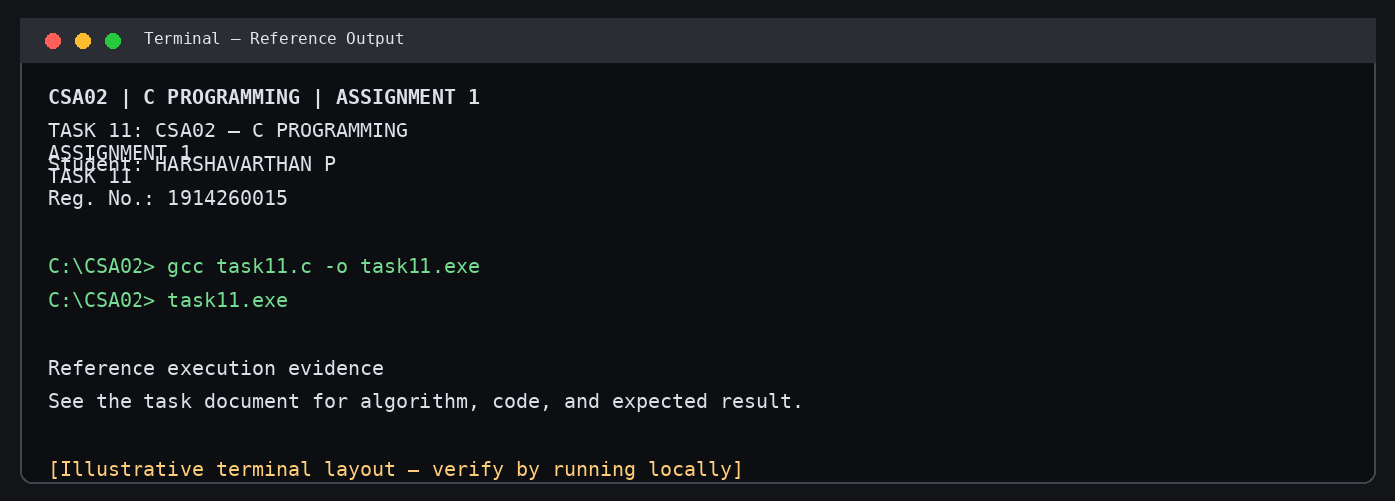
Illustrative terminal-style output screenshot

